Cascade Elementary School
IB Learner Profile
Distance Learning Choice Board
Day 1 Focus: Caring    Task:  Make a gift or greeting card for a family or friend. | Day 2 Focus: Open-Minded    Task:  Missing your friends? Spend some time communicating with them using Facetime, Skype, Zoom or even simply the telephone | Day 3 Focus: Thinker    Task:  Make your own mini-golf course in your living room. Spend some time researching your ideas. | Day 4 Focus: Courageous    Task:  Find a treat recipe. Work with an adult in your house to  create the special treat. Enjoy it! | Day 5 Focus: Reflection    Task:  Sort through old photos. Use the ones that you feel are most special and make a scrapbook of your memories.
Day 6 Focus: Principled  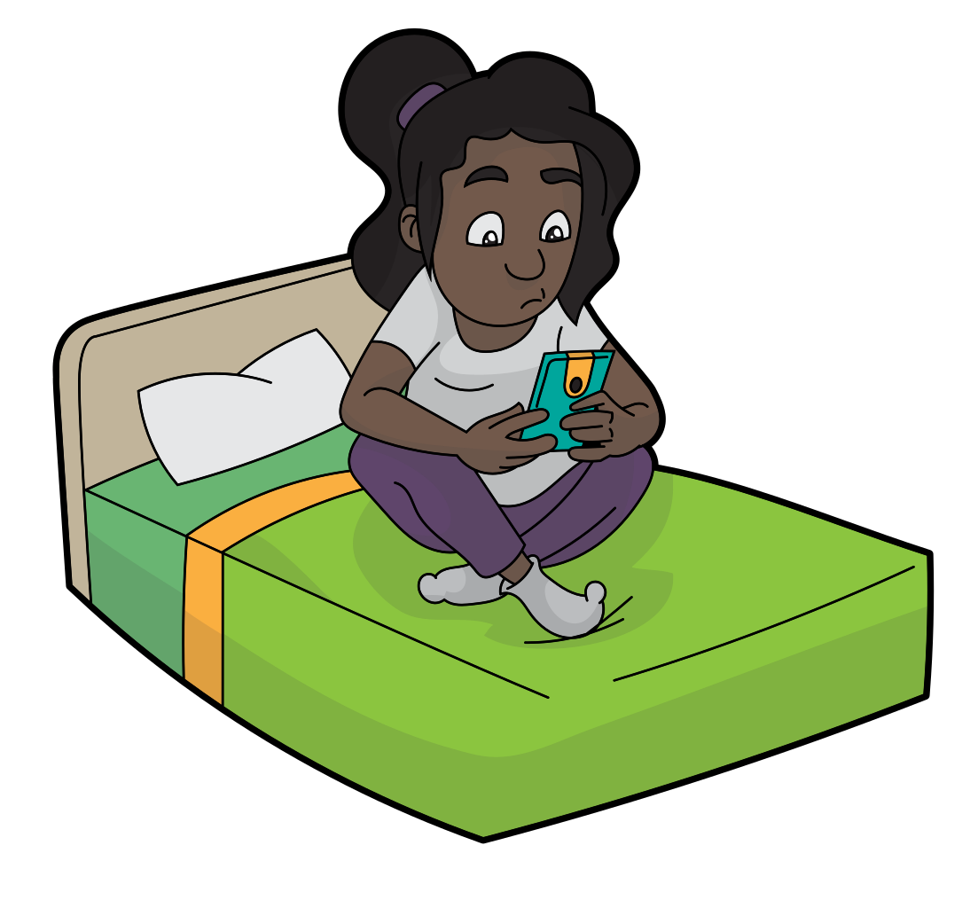  Task:  Organize your room! Sort through your belongings. What is still important to you? What can you donate to someone else? | Day 7 Focus: Inquirer    Task:  Go out into your neighborhood and find things you can learn more about. Come back and research those items. | Day 8 Focus: Knowledgeable    Task:  Have a family “film day” together. Watch your favorite movie and then write a review or draw a movie poster about the movie. | Day 9 Focus: Open-Minded    Task:  Work with an adult and explore ways to take care of plants. Listen to how adults take care of plants. | Day 10 Focus: Balanced    Task:  Go outside and create a game for your friends to play. Write down the directions and rules for the players.

